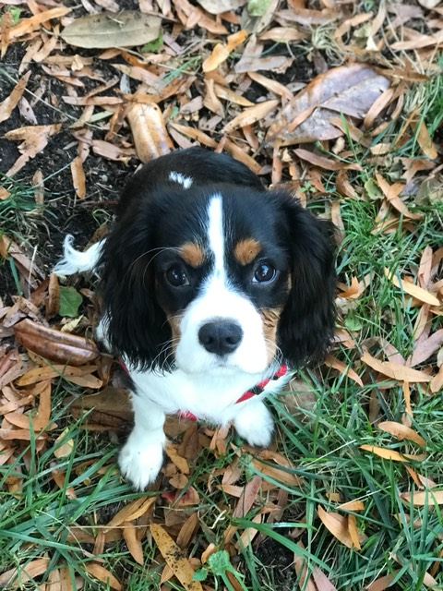 |  | Cavalier King Charles Spaniel  Puppy Application  Application Date: ____________________________________  Applicant Name: ______________________________________________________  Address: ______________________________________________  City: _______________________ State: _______ Zip: _________  Background:  - Have you owned a cavalier or other dog before? ________________________________________________  - Do you spend extended hours away from your home? _________________________________________  - If so, what plan do you have for your puppy (and adult dog) while you’re away? __________________  - Do you have children? If so, how many and what are their ages? _________________________________________  - Are there any other pets in your home? If so, type and number: _________________________________________________  - Is anyone in your house allergic to dog fur, or dander? ________________________________________  General:  - What type of home do you have? Circle One  Mobile Home Apartment Townhome Single Family  - What size yard do you have? ____________________  - Will your puppy be allowed on your furniture? _____  - Do you plan on signing up for a training program? __________________________________________________  - If so, which program? ____________________________  - How do you plan to pick up your puppy (we do not ship): __________________________________________________  Health Care  - Have you chosen a veterinarian, and the name? __________________________________________________  - Have you researched and selected dog food?  __________________________________________________  - Have you researched and selected a Flea/Tick control? If so, please list: __________________________________________________  - Have you researched and selected a HeartWarm preventative? If so, please list:  __________________________________________________  - Have you researched and purchased a harness and leash? ______________________________________  Additional Notes:  ________________________________________________________________________________________________________________________________________________________________________  Applicant Signature:  ________________________________________________________  Application Accepted/Denied: ___________________  Serenity Farm Signature:  ________________________________________________________

Shannon’s Contact
PHONE:
703-362-7935

WEBSITE:
Serenityfarmpuppies.com

EMAIL:
Serenityfarmpups@yahoo.com

